AHP and Delphi Method based Attack-capability Evaluation Methodology

Mun-soo Kong, Jung-won Choi, Gang-soo Lee

Dept. of Computer Engineering, Han Nam Univ., Dae-jeon, Korea
Asgard0917@gmail.com, mireca@naver.com, gslee@hnu.kr

Abstract

Analyzing and countering a cyber-attack, we should classify and evaluate attack-capability of an attacker. We propose a classification scheme for cyber attackers, six evaluation views, and their relative weights by means of the AHP (analytic hierarchy process) method. Delphi coordination method is used for the purpose of minimizing the uncertainly and bias in evaluating attack-capability of an attacker. Proposed methods are implemented in our capability evaluation support tool.

Keywords-component; Cyber-attack-capability, evaluation, classification Scheme, AHP, Delphi

I. Introduction

Estimating attack-capability of cyber-attacker for the purposes of information security management, we can use conventional criteria of the views of attack-capability such as attacker’s intent, knowledge, chance, and level of tool in CEM [1], SP 800-30 [2], and model for evaluation of nation level attack-capability such as C2M and CMM [3,4]. However, they did not consider relative weight among views and the uncertainty of evaluation.
To cope with the problems, we have researched and developed a cyber-attack capability evaluation methodology and supporting tool, which are based on 6 evaluation views, AHP and Delphi coordination method [5,6].
The relative weights among views are estimated by means of the AHP. The uncertainty of evaluation is resolved by using the Delphi. To develop a new method, we have survey on classification scheme of attacker (or threat-source, threat-agent, adversary, actor, attack agent) such as SurfWatch [7], SP 800-30, PKB [8]. Jouini [9], OCTAVE [10], PRAHA [11]. And, we have surveied attack capability evaluation criteria such as SSE-CMM [12], CEM, and SP 800-30.
We design evaluation criteria and method in Section II. It is a framework of attack-capability evaluation. An evaluation support tool is presented in Section III. We discuss and conclude in Section IV and V.

II. Evaluation Criteria and Method

A. Classification scheme of attackers
We propose a classification scheme of cyber attackers (or attack agent) by extending SurfWatch and SP 800-30. Overview of the schema is as follows:.

A1. Individual:
A1.1 Person, A1.2 Cyber terrorist
A2. Nation:
A2.1 Law Enforcement/Authority, etc.
A3. Group:
A3.1 Hacktivist, A3.2 Organized Crime
A4. Organization:
A4.1 Organization, A4.2 Information Security, A4.3 State-sponsored
A5. Environmental:
A5.1 Nature
A6. IT infrastructure:
A6.1 infrastructure, etc.
A7. Unknown :
A7.1 Identity Unknown, etc.

B. Attack evaluation criteria
We suggest attack-capability evaluation criteria, which have 6 views of capability, as a result of survey on success possibility of attack in CEM and capability, intend, target scale in SP 800-30. Each view is consisted of 5 levels of capability. We assume that capability of an attacker means the possibility of success of attacker. Description of criteria of views is omitted here.

Motivation of attack (MO): Examples of MO are political, religious, economic, social, culture. Criteria, that is coms from SP 800-30, is listes as follows:

L1: Seeks to undermine, severely impede, or destroy a core mission or business function, program, or enterprise by exploiting a presence in the organization’s IS or infra. Is concerned about disclosure of tradecraft only to the extent that it would impede its ability to complete stated goals.
L2: Seeks to undermine/impede critical aspects of a core mission or business function, program, or enterprise, or place itself in a position to do so in the future, by maintaining a presence in the organization’s IS or infra.. Is very concerned about minimizing attack detection/disclosure of tradecraft, particularly while preparing for future attacks.
L3: Seeks to obtain or modify specific critical or sensitive information or usurp/disrupt the organization’s cyber resources by establishing a foothold in the organization’s IS or infra.. Is concerned about minimizing attack detection/disclosure of tradecraft, particularly when carrying out attacks over long time periods. Willing to impede aspects of the organization’s missions/business functions to achieve these ends.
L4: Actively seeks to obtain critical or sensitive information or to usurp/disrupt the organization’s cyber resources, and does so without concern about attack detection/disclosure of tradecraft.
L5: Seeks to usurp, disrupt, or deface the organization’s cyber resources, and does so without concern about attack detection/disclosure of tradecraft.

Resource for attack (RE): Examples of RE are time, attacking tool, budget, man-power etc.). Criteria is listed below:

L1: Familiar with the underlying algorithms, protocols, hardware, structures, security behaviour, principles and concepts of security employed. Can very expertise and complex attack.
L2: Understanding security by defined procedure. Advanced attacking by using his resource. Having various attack skills.
L3: Familiar with the security behaviour of the product or system type. Having sufficient resources for attack. Having middle level of ability, knowledge, skill of attack
L4: Understanding security process. Lack of resource and ability of attack. Having limited attack skill.
L5: No particular expertise as well as ability of attack.

Knowledge of attacker (KN): The more knowledge of information security (e.g., cryptology, security protocol, vulnerability analysis), the higher attack-capability. .). Criteria is listed below:

L1: Familiar with the underlying algorithms, protocols, hardware, structures, security behaviour, principles and concepts of security employed. Can very expertise and complex attack.
L2: Understanding security by defined procedure. Advanced attacking by using his resource. Having various attack skills.
L3: Familiar with the security behaviour of the product or system type. Having sufficient resources for attack. Having middle level of ability, knowledge, skill of attack
L4: Understanding security process. Lack of resource and ability of attack. Having limited attack skill.
L5: No particular expertise as well as ability of attack.

Knowledge of target of an attack (TA): Examples of Knowledge about Target of Attack(TOA) are operation profile, vulnerability, system structure, security policy. .). Criteria is listed below:

L1: Having critical information about identification and exploitation of vulnerability
L2: Having sensitive information
L3: Having generally restricted information
L4: Having part of public information
L5: No information about target of attack

Potential of an attack (PO): PO is a property of both TOA and attacker because an attack can exploit it. If an attacker can conspire with another security manager, then the attack-capability will be very high capability. Criteria is listed below:
L1: Possible to conspired with important person such as internal officer and manager
L2: Possible to conspired with general attack
L3: Possible to vulnerability detour attack
L4: Possible to general attack
L5: Possible to identify intend of attack priory

Exposure duration for an attack (ED): The longer exposure attack-surface or vulnerability of target of attack (TOA), the higher attack-capability is. .). Criteria is listed below:

L1: more than several months
L2: more than 1 month
L3: within 1 month
L4: within 1 day
L5: within 1 hour

C.Estimation of weight of capability views
We estimate weights of capability views by means of AHP method as shows Table I. It presents a final result which might varied depending on security policy of organization and evaluators.

TABLE I
WEIGHTS OF THE VIEWS

 | MO | RE | KN | TA | PO | ED | Weight
MO | 0.355 | 0.457 | 0.427 | 0.658 | 0.188 | 0.076 | 0.360
RE | 0.051 | 0.065 | 0.183 | 0.132 | 0.062 | 0.014 | 0.085
KN | 0.051 | 0.022 | 0.061 | 0.026 | 0.312 | 0.379 | 0.142
TA | 0.070 | 0.065 | 0.305 | 0.132 | 0.312 | 0.379 | 0.210
PO | 0.118 | 0.065 | 0.012 | 0.026 | 0.063 | 0.076 | 0.060
ED | 0.355 | 0.326 | 0.012 | 0.026 | 0.063 | 0.076 | 0.143
D. Evaluation of attack-capabilitys
The attack-capability of an attacker can be evaluated by multiple evaluators by means of Delphi method, which is a decision making method in multiple and uncertainty situation. Final level of each view is obtained by three (or more) evaluators and three rounds of the evaluation. The attack-capability is visualized and characterized by a Rader graph as shows in Fig.1.

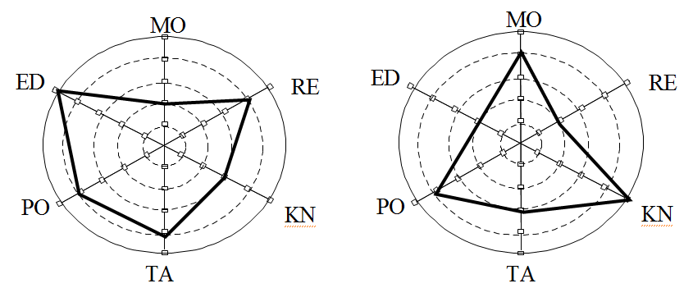

Figure 1. Example Rader graphs of two attacker’s attack-capability

Table II preseents a Delphi coordination procedure with 3 round and 3 evaluators.
Attacker’s attack-capability = ∑_{views} (weight*level) = 0.360*3.333 + 0.085*3 + 0.142*4.33 + 0.210*4.33 + 0.060*3.667 + 0.143*3 = 3.598.
That is, attack-capability is weighted average of levels of six views.

TABLE II
EXAMPLE VALUE OF DELPHI METHOD
Views | Weight | Level | Round1 |  |  | Round2 |  |  | Round3
Views | Weight | Level | E11 | E12 | E13 | E21 | E22 | E23 | E31 | E32 | E33
MO | 0.360 | 3.333 | 2 | 3 | 4 | 3 | 3 | 4 | 3 | 3 | 4
RE | 0.085 | 3 | 3 | 3 | 4 | 3 | 3 | 3 | 3 | 3 | 3
KN | 0.142 | 4.33 | 3 | 5 | 4 | 4 | 5 | 4 | 4 | 5 | 4
TA | 0.210 | 4.33 | 5 | 5 | 4 | 5 | 5 | 4 | 4 | 4 | 5
PO | 0.060 | 3.667 | 4 | 2 | 5 | 3 | 3 | 4 | 4 | 3 | 4
III.Evaluation Support Tool

We have developed an evaluation support tool as shows in Fig. 2. The tool support evaluation processes as proposed in Section 2. The attack-event DB, that is core of the tool, is a DB of information about attackers, attack methods, and TOA (or asset). If much security information is stored, then the attack-event DB will become a security event Big-data. It will be useful for detection, analysis, forecasting, and counting of security attacks.
As shows in Fig. 2, one manager, at least three evaluators, and multiple users are involved in evaluation processes. Evaluation is conducted by the following processes.

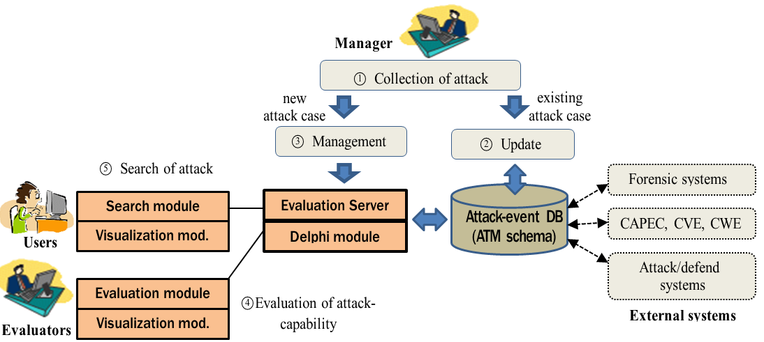
Manager

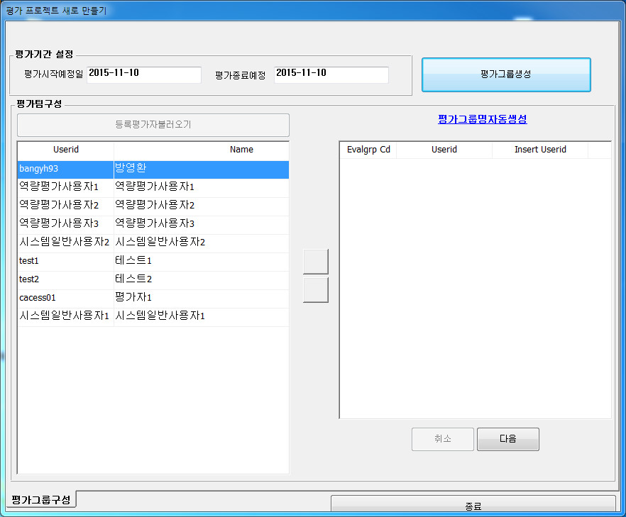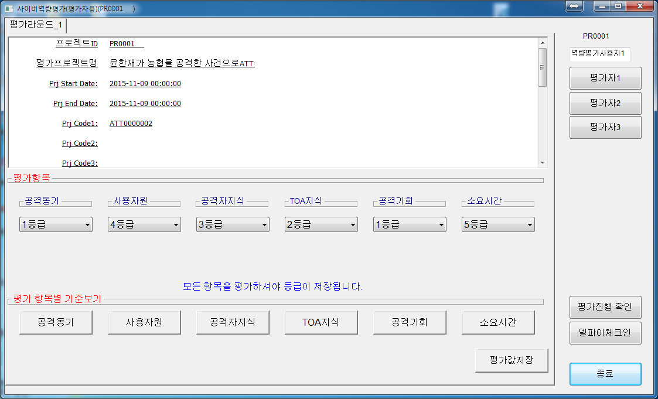
Figure 2. Attack-capability evaluation process and user interfaces

Manager collect collections of attack events form various sources suc as WWW. If the event is a new attack case, then evaluate attribute such as attack-capability, else updates the corresponding attack-event DB. Evaluators evaluate six views of attack-capability by using the Delphi module., and store the result into corresponding attribute in attack-event DB. Users can searech attack information from the attack-event DB for his purpose.
The tool referes to external security database or systems such as some forensic and attack/defend systems and CAPEC (common attack pattern enumeration and classification), CVE (common vernerability enum.) and CWE (common weak enum.) of MITRE. Thus, evaluators can browse much more cyber attack information.
The evaluation support tool have the following modules:
- Search module
- Visualization module
- Evaluation module
- Evaluation Server
- Delphi module
- Attack-event DB

Note that schema of the Attack-event DB is ATM (Attack-Target-Method) which was presented at some conference[13].

IV. Discussion

We differentiate our approach from other works such as CEM, SP 800-30, CMM, SurfWatch, PKB, OCTAVE, PRAHA, SSE-CMM, as follows: (1) A hierarchical attacker classification scheme by extending SurfWatch. (2) Modification of 6 views for attack-capability from CEM and NIST SP 800-30. (3) Weighing of 6 views by using AHP method. (4) Application of Delphi method for the purpose of subjectivity and uncertainty in evaluation. (5) Development of evaluation support tool, which is based on attack-event DB.
Note that AHP and Delphi methods might be useful tools for information security magament which has the uncertainty and the subjectivity in decision making.

V. Conclusion

In this paper we research and develop attack-capability evaluation criteria and its supporting tool. We merge results of survey on related area and conventional methods such as AHP and Delphi method.
Refinement of attacker classification schema, research on executable specification of attack method, and continuous enrichment of security-event DB are remained as further studies.

References

[1] CCMB-2012-09-004, “Common Methodology for Information Technology Security Evaluation”, Ver. 3.1, Rev. 4, Sep. 2012.[2] NIST SP 800-30, Rev.1, “Guide for conducting risk assessments”, 2012. 9.
[3] Cybersecurity Capability Maturity Model (C2Ms), Dept. of Engineering, Dept. of Homeland Security, U.S.A., Ver.1.1, Feb. 2014.
[4] Cybersecurity Capability Maturity Model (CMM), Ver.1.2, Global cyber security capability centre, Univ. of Oxford, Dec. 2014.
[5] June-sung Choi, et al., “Evaluation Method using Analytic Hierarchy Process for C4I SW Secure Coding Rule Selection”, Journal of KICS, Vol. 13, No. 8, , pp. 651-662, Aug. 2013.
[6] Sung-hwan Song, et al., “Application of the Delphi Technique in Modifying AHP Method”, Korea Management Science Review, Vol. 26, No.1, pp. 53-64, March 2009.
[7] https://www.surfwatchlabs.com/
[8] http://niatec.info/viewpage.aspx?id=44. http://pagenotes.com/about/writings/CCPKB/User_Guide/1_Background.htm
[9] M. Jouini, et al., “Classification of Security Threats in Information Systems”, 5’th Intl. Conf. on Ambient System, Networks and Technologies (ANT-2014).
[10] Richard A. et al., “Introducing OCTAVE Allegro: Improving the Information Security Risk Assessment Process”, May 2007.
[11] Jung-ho Ko and Gang-soo Lee, “A Threats Statement Generation Method for Security Environment of Protection Profile”, Journal of Society for e-Business Studies, Vol. 8, No. 3, , pp.69-86, Aug. 2003.
[12] ISO/IEC 21827: “Systems Security Engineering - Capability Maturity Model (SSE-CMM)”, 2008.
[13] Nam-jung, Mun-soo Kong, Gang-soo Lee., An Attack-Target-Method Schema for Cyber Attack Event Database, IEEE Internal Conference on Electronic Information and Communication Technology (ICEICT 2016), Aug. 20-22, Harbin, China, 2016.

